Programming Exercise 1: Linear Regression

Machine Learning

# Introduction

In this exercise, you will implement linear regression and get to see it work on data. To get started with the exercise, you will need to download the starter code and unzip its contents to the directory where you wish to complete the exercise. If needed, use the cd command in Octave/MATLAB to change to this directory before starting this exercise.

You can log into your CougarNet and download MATLAB from this website: <https://uh.edu/software-downloads/index.php>.

## Files included in this exercise

ex1.m - Octave/MATLAB script that steps you through the exercise ex1 ex1data1.txt - Dataset for linear regression with one variable

[y] plotData.m - Function to display the dataset

[y] computeCost.m - Function to compute the cost of linear regression

[y] gradientDescent.m - Function to run gradient descent

[†] gradientDescent_incorrect.m - Function to run gradient descent in

a wrong way

yindicates files you will need to complete

†indicates optional exercises

## Files needed to be submit

[1] ML_ex1 – Include all the code (You need to complete plotData.m, computeCost.m, gradientDescent.m by yourself)

[2] ex1_report – Directly give the answers of three questions:

(1) Figure of Training data with linear regression fit

(2) Initial cost J when theta are all zeros

(3) Prediction on profits in areas of 45,000 people

(4) Minimum cost J and values of theta when we do not update them simultaneously (optional)

Throughout the exercise, you will be using the scripts ex1.m. This scripts set up the dataset for the problems and make calls to functions that you will write. You do not need to modify it. You are only required to modify functions in other files, by following the instructions in this assignment.

## Where to get help

The exercises in this course use Octave[1] or MATLAB, a high-level programming language well-suited for numerical computations.

At the Octave/MATLAB command line, typing help followed by a function name displays documentation for a built-in function. For example, help plot will bring up help information for plotting. Further documentation for Octave func-tions can be found at the [Octave documentation pages.](http://www.gnu.org/software/octave/doc/interpreter/) MAT- LAB document-tation can be found at the [MATLAB documentation pages.](http://www.mathworks.com/help/matlab/?refresh=true)

Do not look at any source code written by others or share your source code with others.

# Linear regression with one variable

In this part of this exercise, you will implement linear regression with one variable to predict profits for a food truck. Suppose you are the CEO of a restaurant franchise and are considering different cities for opening a new outlet. The chain already has trucks in various cities and you have data for profits and populations from the cities.

The file ex1data1.txt contains the dataset for our linear regression problem. The first column is the population of a city and the second column is the profit of a food truck in that city. A negative value for profit indicates a loss.

The ex1.m script has already been set up to load this data for you.

## Plotting the Data

Before starting on any task, it is often useful to understand the data by visualizing it. For this dataset, you can use a scatter plot to visualize the data, since it has only two properties to plot (profit and population). (Many other problems that you will encounter in real life are multi-dimensional and can’t be plotted on a 2-d plot.)

In ex1.m, the dataset is loaded from the data file into the variables *X*

and *y*:

data = load('ex1data1.txt'); %read comma separated data

X = data(:, 1); y = data(:, 2);

m = length(y); %number of training examples

Next, the script calls the plotData function to create a scatter plot of the data. Your job is to complete plotData.m to draw the plot; modify the file and fill in the following code:

plot(x, y,'rx','MarkerSize', 10); %Plot the data

ylabel('Profitin$10,000s'); %Set the y-axis label

xlabel('PopulationofCityin10,000s'); %Set the x-axis label

Now, when you continue to run ex1.m, our end result should look like Figure 1, with the same red “x” markers and axis labels.

To learn more about the plot command, you can type help plot at the Octave/MATLAB command prompt or to search online for plotting doc- umentation. (To change the markers to red “x”, we used the option ‘rx’ together with the plot command, i.e., plot(..,[your options here],.., ‘rx’); )

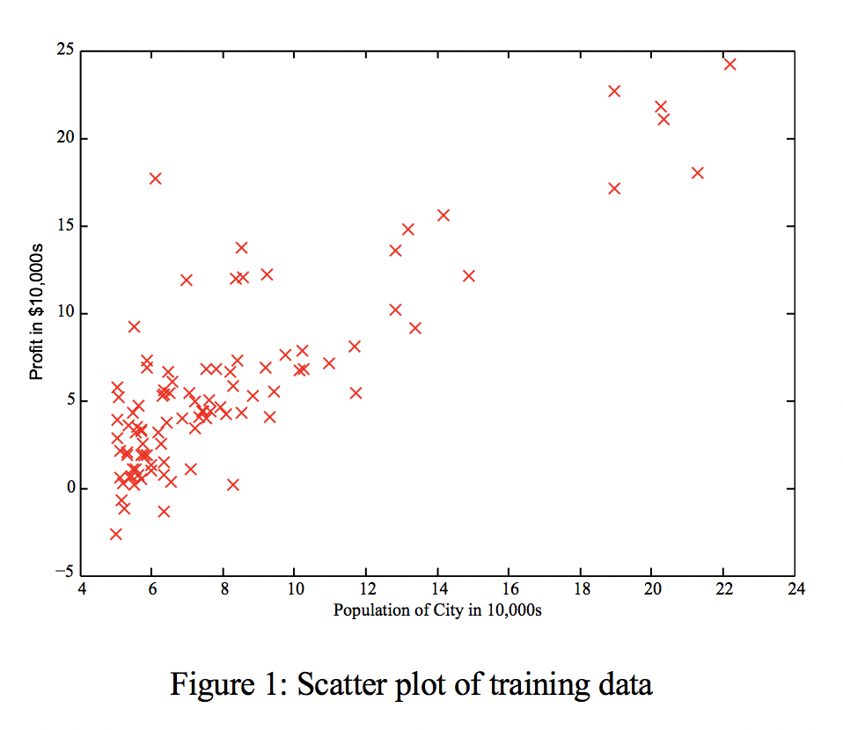

## Gradient Descent

In this part, you will fit the linear regression parameters *θ* to our dataset using gradient descent.

### Update Equations

The objective of linear regression is to minimize the cost function

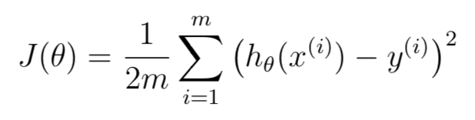

where the hypothesis *hθ*(*x*) is given by the linear model

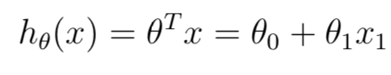

Recall that the parameters of your model are the *θj* values. These are the values you will adjust to minimize cost *J* (*θ*). One way to do this is to use the batch gradient descent algorithm. In batch gradient descent, each iteration performs the update

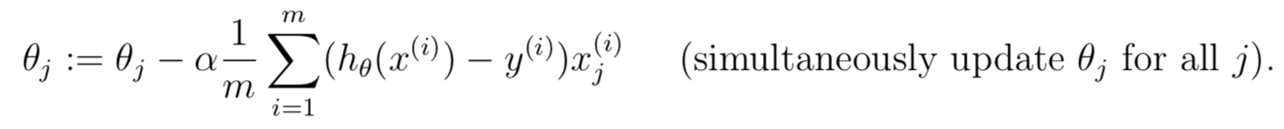

With each step of gradient descent, your parameters *θj* come closer to the optimal values that will achieve the lowest cost *J* (*θ*).

**Implementation Note:** We store each example as a row in the X matrix in Octave/MATLAB. To take into account the intercept term (*θ*0), we add an additional first column to X and set it to all ones. This allows us to treat *θ*0 as simply another ‘feature’.

### Implementation

In ex1.m, we have already set up the data for linear regression. In the following lines, we add another dimension to our data to accommodate the *θ*0 intercept term. We also initialize the initial parameters to 0 and the learning rate alpha to 0.01.

X = [ones(m, 1), data(:,1)]; %Add a column of ones to x

theta = zeros(2, 1); %initialize fitting parameters

iterations = 1500;

alpha = 0.01;

* + 1. **Computing the cost** *J* (*θ*)

As you perform gradient descent to learn minimize the cost function *J* (*θ*), it is helpful to monitor the convergence by computing the cost. In this section, you will implement a function to calculate *J* (*θ*) so you can check the convergence of your gradient descent implementation.

Your next task is to complete the code in the file computeCost.m, which is a function that computes *J* (*θ*). As you are doing this, remember that the variables *X* and *y* are not scalar values, but matrices whose rows represent the examples from the training set.

Once you have completed the function, the next step in ex1.m will run computeCost once using *θ* initialized to zeros, and you will see the cost printed to the screen.

### Gradient descent

Next, you will implement gradient descent in the file gradientDescent.m. The loop structure has been written for you, and you only need to supply the updates to *θ* within each iteration.

As you program, make sure you understand what you are trying to optimize and what is being updated. Keep in mind that the cost *J* (*θ*) is parameterized by the vector *θ*, not *X* and *y*. That is, we minimize the value of *J* (*θ*) by changing the values of the vector *θ*, not by changing *X* or *y*.

A good way to verify that gradient descent is working correctly is to look at the value of *J* (*θ*) and check that it is decreasing with each step. The starter code for gradientDescent.m calls computeCost on every iteration and prints the cost. Assuming you have implemented gradient descent and computeCost correctly, your value of *J* (*θ*) should never increase and should converge to a steady value by the end of the algorithm.

After you are finished, ex1.m will use your final parameters to plot the linear fit. The result should look something like Figure 2:

Your final values for *θ* will also be used to make predictions on profits in areas of 35,000 people. Note the way that the following lines in ex1.m uses matrix multiplication, rather than explicit summation or looping, to calculate the predictions. This is an example of code vectorization in Octave/MATLAB.

predict1 = [1, 3.5] * theta;

## Debugging

Here are some things to keep in mind as you implement gradient descent:

* + - Octave/MATLAB array indices start from one, not zero. If you’re storing *θ*0 and *θ*1 in a vector called theta, the values will be theta(1) and theta(2).
    - If you are seeing many errors at runtime, inspect your matrix operations to make sure that you’re adding and multiplying matrices of compatible dimensions. Printing the dimensions of variables with the size command will help you debug.
    - By default, Octave/MATLAB interprets math operators to be matrix operators. This is a common source of size incompatibility errors. If you don’t want matrix multiplication, you need to add the “dot” notation to specify this to Octave/MATLAB. For example, A*B does a matrix multiply, while A.*B does an element-wise multiplication.

## Visualizing *J* (*θ)*

To understand the cost function *J* (*θ*) better, you will now plot the cost over a 2-dimensional grid of *θ*0 and *θ*1 values. You will not need to code anything new for this part, but you should understand how the code you have written already is creating these images.

In the next step of ex1.m, there is code set up to calculate *J* (*θ*) over a grid of values using the computeCost function that you wrote.

%initialize J_vals to a matrix of 0's

J_vals = zeros(length(theta0_vals), length(theta1_vals));

%Fill out J_vals

For i = 1:length(theta0_vals)

for j = 1:length(theta1_vals)

t = [theta0_vals(i); theta1_vals(j)];

J_vals(i,j) = computeCost(x, y, t);

end

end

After these lines are executed, you will have a 2-D array of *J* (*θ*) values. The script ex1.m will then use these values to produce surface and contour plots of *J* (*θ*) using the surf and contour commands. The plots should look something like Figure 3:4

 

3

(a) Surface (b) Contour, showing minimum

Figure 3: Cost function *J* (*θ*)

The purpose of these graphs is to show you that how *J* (*θ*) varies with changes in *θ*0 and *θ*1. The cost function *J* (*θ*) is bowl-shaped and has a global mininum. (This is easier to see in the contour plot than in the 3D surface plot). This minimum is the optimal point for *θ*0 and *θ*1, and each step of gradient descent moves closer to this point.

# Optional Exercise

If you have successfully completed the material above, congratulations! You now understand linear regression and should able to start using it on your own datasets.

There is an optional exercise which can help you get a better understanding. if you are able to do it, we encourage you to complete it as well.

We know that the correct gradient descent mode is that all variables change simultaneously. What if they do not change simultaneously?

Change gradientDescent.m to gradientDescent_incorrect.m. Get the minimum cost J and the values of theta. See if the results are the same with the code when we update two parameters simultaneously.

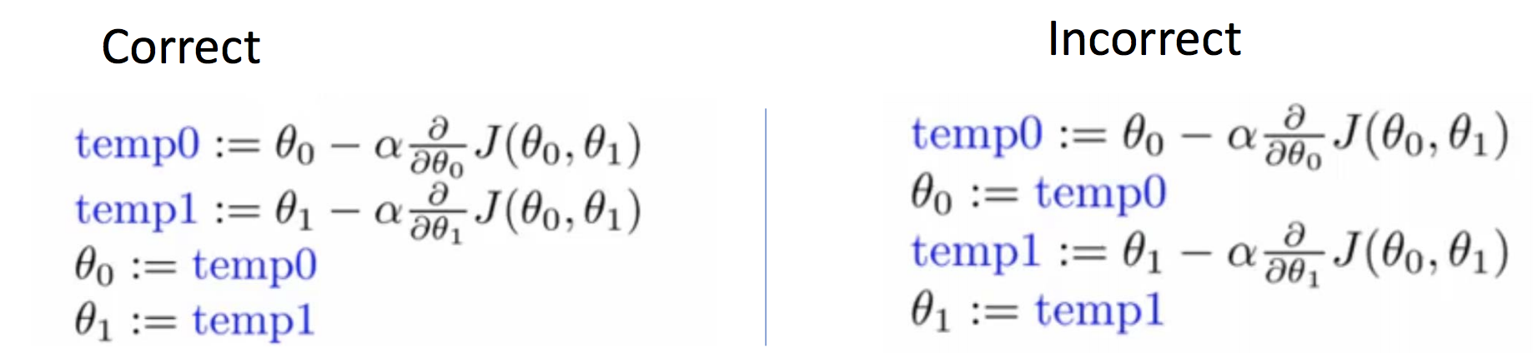

# Submission and Grading

After completing various parts of the assignment, be sure to submit all the files needed to blackboard. The following is a breakdown of how each part of this exercise is scored.

|  |  |  |
| --- | --- | --- |
| **Part** | **Related code file** | **Points** |
| Figure of Training data with linear regression fit | PlotData.m  gradientDescent.m | 20 points |
| Compute initial cost for one variable  Gradient descent for one variable | computeCost.m  gradientDescent.m | 30 points  50 points |
| Total Points |  | 100 points |

You are allowed to submit your solutions multiple times, and we will take only the highest score into consideration.

1. Octave is a free alternative to MATLAB. For the programming exercises, you are free

   to use either Octave or MATLAB.